**Name: Rayan Rawat**

**Cohort: Mark Zuckerberg**

**RollNo: 150096724141**

**Problem Statement Number: 147**

**Problem Statement:**

147: MERN Stack - Development Weather Dashboard: Context: Forecasts, alerts. Learners build WeatherWatch MERN. Challenge: Live data, histories, alerts. Custom locations. Requirements: Core Features include Frontend: Maps, charts; Backend: Weather APIs mock; Database: Locations, alerts; Authentication: JWT; UI/UX: Forecasts. Advanced Features Optional): Clothing suggests. History. Deliverables: Dashboard. Example User Flow: Add city. View 7-day. Rain alert.

**Website Link :** [**Weather_Watch**](https://rayan-141.github.io/Weather_Watch/)

**Proposed Solution:**

Weather Watch is a full-stack web application that provides **live weather updates, 21-day forecasts, current location-based weather, and simple weather alerts**. It is built using the **MERN stack (MongoDB, Express.js, React.js, and Node.js)** and uses **free weather APIs like Open-Meteo** to fetch real-time weather data.

The application shows important weather details such as **temperature, humidity, wind speed, UV index, and air quality (AQI)** in a clean dashboard. Users can also see the weather forecast using simple UI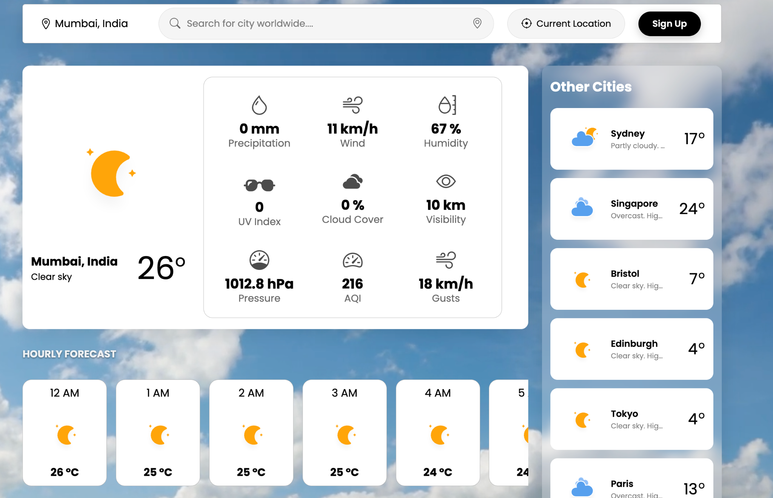

The backend is developed using **Node.js and Express.js** and provides APIs for **user authentication using JWT** and weather data fetching. User passwords are **securely hashed using bcrypt** and stored in **MongoDB with Mongoose**.

The frontend is built with **React.js** and uses a component-based structure. The dashboard opens by default and displays weather cards, a **21-day forecast chart**, simple **JavaScript alert popups for weather alerts**, and **basic clothing suggestions.**

**Main Weather Dashboard :**

| **Changing City :** | **Hourly Forecast (New York) :** |
| --- | --- |
| **21Day Forecast Chart (New York)** | **Today Temperature Graph And Clothing Suggestions:** |
| **Weather Alert (New York):** | **Other Cities :** |

